講演要旨

空白

**Assessment and Prediction of Shoreline Change**

**Using Free and Open Source CoastSat & AMBUR Toolkits**

Job THOMAS, Tatsuya NEMOTOand Venkatesh RAGHAVAN

Department of Geosciences, Graduate School of Science, Osaka Metropolitan University,

3-3-138 Sugimoto Sumiyoshi-ku, Osaka, 558-8585, Japan E-mail: sw23079s@st.omu.ac.jp

*明朝(約6.5mm)*

**Key words:** Shoreline prediction, Shoreline change analysis, Transect method, Open source.

空白

1. Introduction

Coastal management requires a careful evaluation of shoreline change dynamics, which is important to protect the fragile near-shore environment. This problem becomes particularly crucial due to the impact of climate change and related factors. To understand the dynamics of coastal change, it is important to derive accurate shorelines, and this can be achieved with the help of CoastSat, which extract shorelines from 30+ years of satellite imagery, providing cloud removal, high-resolution coverage, tidal corrections, and a user-friendly interface. (Vos *et al*., 2019).

On the other hand, AMBUR (Analyzing Moving Boundary Using R) provides time-series capabilities (Jackson Jr *et al*., 2012). It's new transect method addresses curved shoreline movements. In this study, we evaluate the efficacy of using CoastSat and AMBUR to gain understandings on shoreline changes, erosion patterns, and future shoreline disposition.

2. Materials and Methods

2.1 Data

The data used for this study are 4 shorelines from 1989, 2003. 2013 & 2023, where shoreline of 2023 was used for validation. These Shorelines were extracted from optical satellites, where beach slope and shoreline elevation were calculated using DEM, and tidal data was obtained from National Oceanographic Centre. Table 1 shows the detailed description of the data and its sources.

2.2 Methodology

The CoastSat toolkit extract shorelines and perform tidal corrections, achieving around 10-meter accuracy. It processes multispectral images from Sentinel-2 and Landsat via Google Earth Engine, applying cloud masking and pansharpening. With the help of MNDWI, and Otsu's threshold (Otsu, 1979), it segments images into land and water pixels, extracting shorelines with the Marching Squares algorithm (Cipolletti *et al*., 2012). Tidal correction, including tidal data, beach slope, and shoreline elevation, normalizes the shoreline positions to mean sea level, providing an accurate long-term shoreline analysis.

The AMBUR toolkit was used to calculate shoreline change rates and predict future shorelines. It starts from collecting baselines and shorelines, then generates transects at regular intervals. For this study 5 different

Table 1: Input data used in this study.

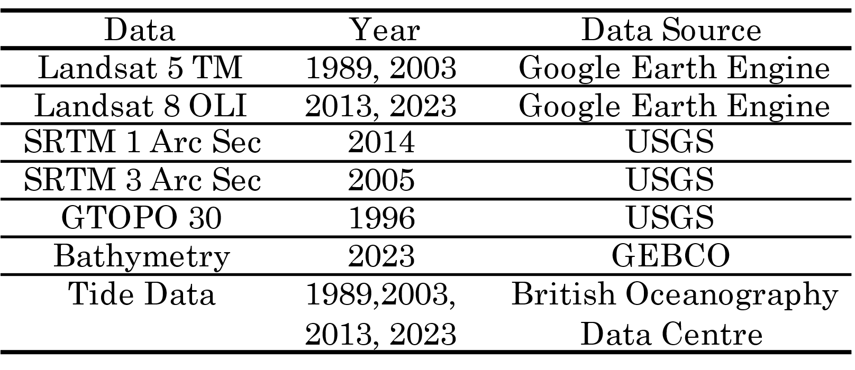

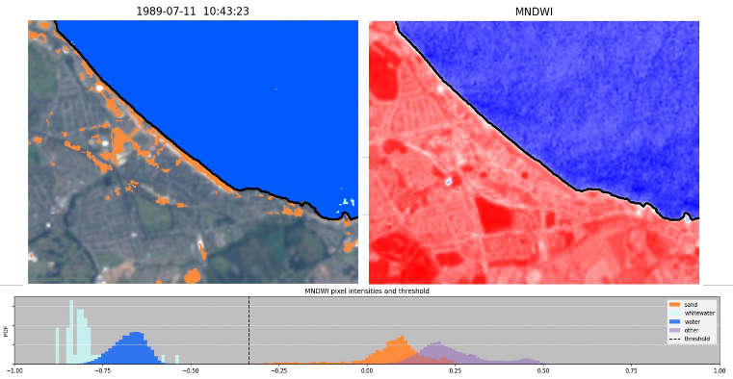

Figure 1: Shoreline Extraction for 1989.

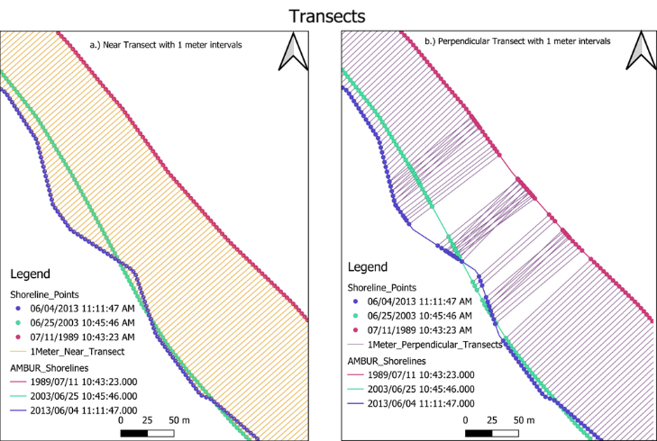

Figure 2: Transect Methods.

intervals of 1 m, 25 m, 50 m, 75 m, and 100 m were used along the shoreline. Two transect types are used: perpendicular and near transects shown in Figure 2.

These transects help measure shoreline positions over time. Shoreline positions are analyzed by calculating

Table 2: Accuracy Assessment & Shoreline Change Rate

|  |  |  |  |  |  |  |
| --- | --- | --- | --- | --- | --- | --- |
| D I | T M | M D | S D | MAE | A R (m/y) | E R (m/y) |
| 1 m | P | 20.66 | 14.26 | 20.67 | 2.36 | -3.95 |
| N | 20.70 | 14.29 | 20.70 | 3.01 | -3.94 |
| 25 m | P | 20.63 | 13.98 | 20.62 | 0.89 | -3.95 |
| N | 20.48 | 14.12 | 20.48 | 2.98 | -3.91 |
| 50 m | P | 20.39 | 14.12 | 20.39 | 0.88 | -3.95 |
| N | 20.17 | 13.87 | 20.17 | 2.98 | -3.91 |
| 75 m | P | 21.56 | 13.77 | 21.57 | 0.80 | -3.66 |
| N | 21.26 | 13.78 | 21.26 | 0.92 | -3.74 |
| 100 m | P | 20.87 | 13.94 | 20.87 | 0.84 | -3.94 |
| N | 20.95 | 14.05 | 20.95 | 0.92 | -3.91 |

D I: Distance Intervals, T M: Transect Methods, P: Perpendicular, N: Near, M D: Mean Distance, S D: Standard Deviation, MAE: Mean Absolute Error, A R: Accretion Rate, E R: Erosion Rate. m: Meter, y: Year.

intersection points and measuring distances from the baseline. Statistical methods, including End Point Rate (EPR), Linear Regression Rate (LRR), and Weighted Linear Regression (WLR), are used to calculate change rates. Predicting future shorelines depends on factors like shoreline change rates calculated using statistical methods (EPR, LRR, WLR), Transect azimuth, Offshore Correction values, latest shoreline, and the forecast period (e.g., 10 years, 50 years) for which the future shoreline position needs to be predicted.

3. Results and Conclusions

In this study, only the End Point Rate statistical method was performed on the shorelines with different transects intervals of 1 m, 25 m, 50 m, 75 m, and 100 m, using both the perpendicular transect method and the near transect method. Table 2 shows the accretion and erosion rates at various distance intervals. It was observed that the near transect method generally yields higher accretion rates as compared to the perpendicular transect method, this is particularly noticeable at the 1 m, 25 m, and 50 m intervals. The perpendicular transect method tends to show slightly higher erosion rates at shorter intervals and the near transect method, however, maintains higher and more consistent accretion rates across all intervals. Figure 3 shows the frequency of distances within a specific range between the predicted and observed shorelines for 1 m interval. The y-axis ranges from 0 to 500, a bar reaching up to 100 means there are 100 cases where the distance between the predicted and observed shorelines fell within the range defined by that bar’s width on the x-axis.

Shorelines for 2023 were forecasted using two transect methods from 1989, 2003, and 2013 coastal data. The results were validated with the actual shoreline of 2023 derived from CoastSat as shown in Table 2. The accuracy assessment provides understanding of shoreline prediction for 2023 using near and perpendicular transect methods. From the results, it can be observed that the mean distances range from approximately 20.17 to 21.56 meters, indicating the average deviation of the distances between the predicted and observed shorelines. The standard deviations have values ranging from 13.77 to 14.29 meters, that suggest the variability of the prediction around the mean. Furthermore, the MAE values provide additional measures of prediction accuracy of 20.17 meters. These findings suggest the near transect method

Figure 3

better captures accretion trends, while both methods reliably measure erosion rates. Overall, the accuracy assessment allows for the comparison of different transect methods and intervals, aiding in the selection of the most suitable approach for future shoreline prediction tasks.

References

Cipolletti, M. P., Delrieux, C. A., Perillo, G. M., and Piccolo, M. C. (2012) Super resolution border segmentation and measurement in remote sensing images. *Computers & Geosciences*, vol.40, pp.87-96.

Jackson Jr, C. W., Alexander, C. R., and Bush, D. M. (2012) Application of the AMBUR R package for spatio-temporal analysis of shoreline change: Jekyll Island, Georgia, USA. *Computers & Geosciences*, vol.41, pp.199-207.

Otsu, N. (1979) A -threshold - selection - method - from gray-level histograms. IEEE –T*ransactions on Systems, Man, and Cybernetics*, vol.9(1), pp.62-66.

https://doi.org/10.1109/TSMC.1979.4310076

Vos, K., Splinter, K. D., Harley, M. D., Simmons, J. A., and Turner, I. L. (2019) CoastSat: A Google Earth Engine-enabled Python toolkit to extract shorelines from publicly available satellite imagery. *Environmental Modelling & Software*, vol.22, 104528.